TANK REMOVAL
Drain all fuel from OEM fuel tank into a government approved fuel container with a grater capacity than fuel tank on vehicle.
The stock fuel lines, petcock, radiator shrouds (some models) & seat need to be removed. When removing any tank mount brackets be sure to note the RIGHT & LEFT SIDE brackets. They must be installed on the appropriate side for the tank to mount properly.

TANK INSTALLATION
Install the IMS gas cap & stock petcock.
The IMS fuel tank installs the same exact manner as the stock fuel tank. Use all the stock hardware and mounting brackets to the IMS tank. Be sure to note the RIGHT & LEFT SIDE brackets. They must be installed on the appropriate sides for the tank to mount properly.
Be sure that the IMS fuel tank is mounted securely & doesn’t bind or in any way inhibit the function of the motorcycle or the rider’s movement.
Ensure that there is no sharp objects, (handle bars, tank mounting bolts, seat bolts etc.) that rub against the tank, they may eventually puncture the tank.
Connect the fuel line & turn the petcock to the closed position, replace the seat & shrouds if necessary, check for any leaks & enjoy your longer ride!

“FOR COMPETITION USE ONLY”
“Legal in California ONLY for racing vehicles
which may never be used upon a highway.”

DISCLAIMER: | Due to uncontrolled variables in the manufacturing process of rotationally molded fuel tanks, the fuel tank may vary in size and shape by up to 7% of the manufacturer’s original listed capacity

“FOR COMPETITION USE ONLY”
“Legal in California ONLY for racing vehicles
which may never be used upon a highway.”

DISCLAIMER: | Due to uncontrolled variables in the manufacturing process of rotationally molded fuel tanks, the fuel tank may vary in size and shape by up to 7% of the manufacturer’s original listed capacity

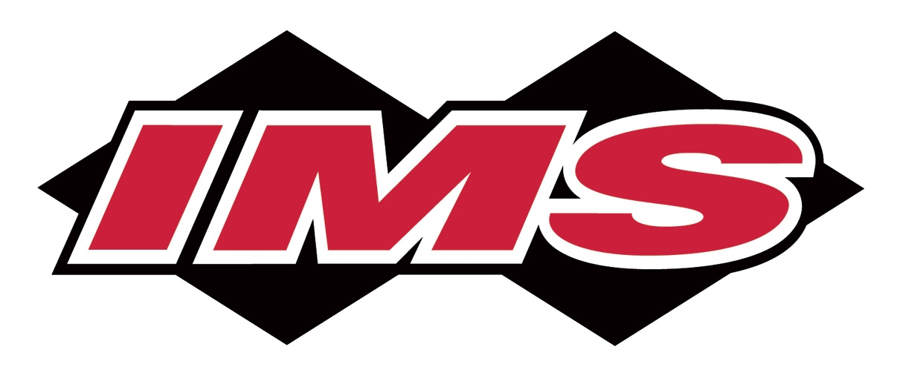

IMS

REPLACEMENT

FUEL TANK:

IMS Tank ID: YZ-9
IMS Part #:
117313

PARTS LIST
(1) Fuel tank
(1) Gas cap & seal
(1) Petcock gasket

STOCK ITEMS TO USE
• petcock & screws
• all mounting hardware

WARNING!
Clean tank interior thoroughly before installation. Install
this fuel tank ONLY in a well ventilated area, as gasoline fumes are EXTREMELY dangerous. DO NOT START OR OPERATE THE VEHICLE IF THERE ARE ANY FUEL LEAKS! IMS recommends that a licensed mechanic do installation. Read all instructions first before beginning installation.

